MORNING WORSHIP SERVICE
Aug 28, 2016

Opening

Opening Prayer/Announcements
K s b c

Keeping His Word through Sunday School, Bible Study and Church Attendance/Worship

Sunday School Bible Studies for August:

August 7th Manage Money Diligently Proverbs 31:13-21
August 14th Invest Money Wisely Ecclesiastes 11:1-6
August 21st Give Money Generously Proverbs 1:23-29
August 28th Love Gets Involved Luke 10:25-37

9:45 a.m. each Sunday – A place for everyone

Worship Hymns

Offering/Offertory

Special Music

Message Bro. David Atwood
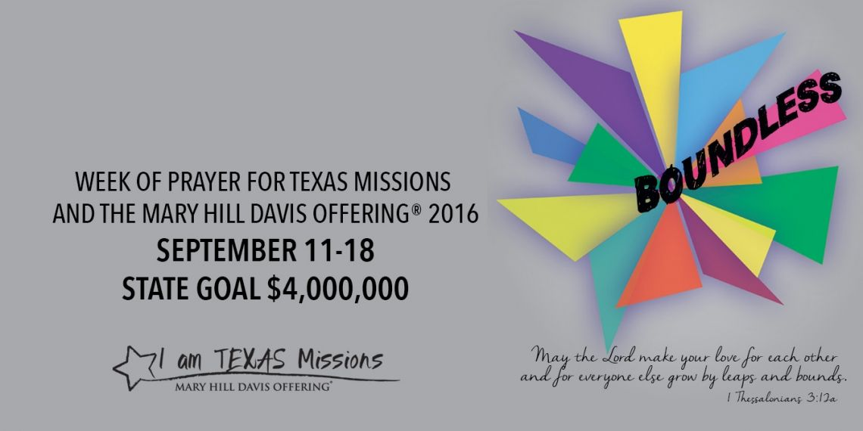

Invitation

Closing Prayer

Evening Service @ 6:00pm

NURSERY – available for children age 0 to Kindergarten

Hostesses for August Ushers for August
Diann Stutes, Evelyn Robinson, Joe Daniel, Mickey Stanford,
Hugo & Carolyne Breithaupt David Condron, Hugo Breithaupt

Immediate Need Prayer List
Prayer & Request Information

(Please complete name & address information on reverse side)

❑ I would like to speak with the Pastor.

❑ I would like more information on this church.

❑ I have Prayer Requests or Needs

Date:

Permission to Publicize:
Church Bulletin  Yes  No
Email Prayer Chain  Yes  No

Prayer Request:

Prayer For
Name
Address
Phone

Given By
Name
Address
Phone
Please Contact By

❑ Card  Phone  Visit

Comments

Pray for unsaid fears and concerns

Pray for Helen Emery as she recovers in rehab and prepares to move to Livingston

